Managed Switch Topology in IVMS4200
For more information on different models, click here.

- From IVMS4200 dashboard choose topology

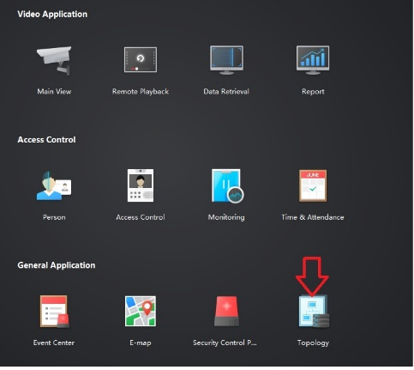

- Currently the below option are supported
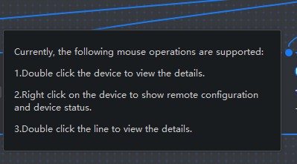

- Topology Overview

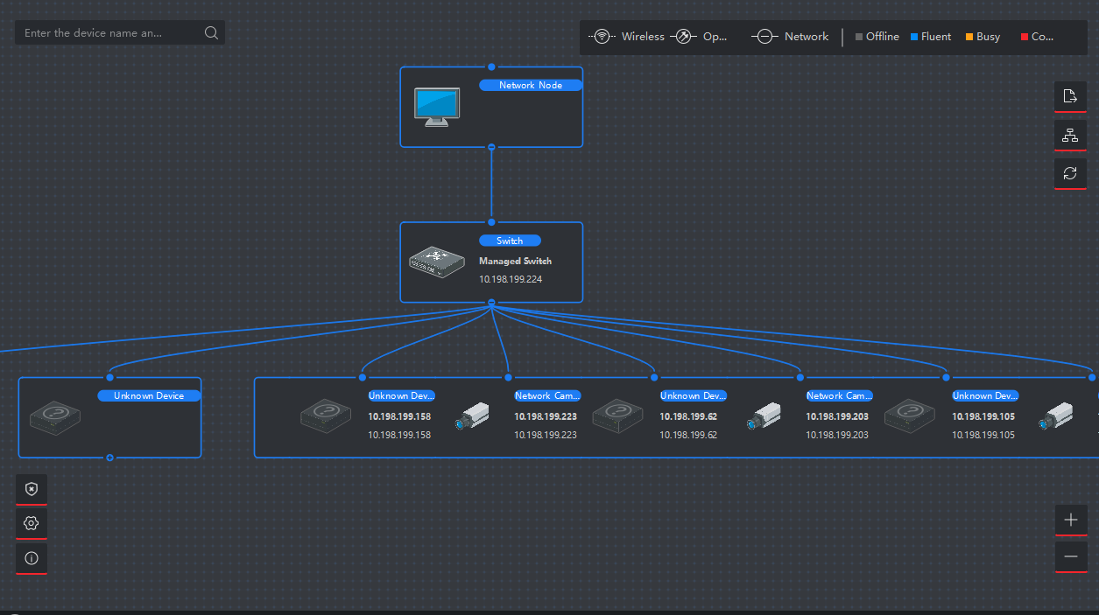

- To get access to the switch detailed status and configuration (Right Click on the Switch)
- Used show the ports, device status, Naming, Events and Remote configuration.

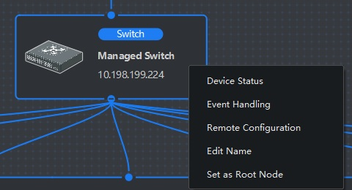

- Under device status it will show (Switch Status, Port Status and Statistics, Poe Port Status)
Ex. Memory, CPU, Poe usage

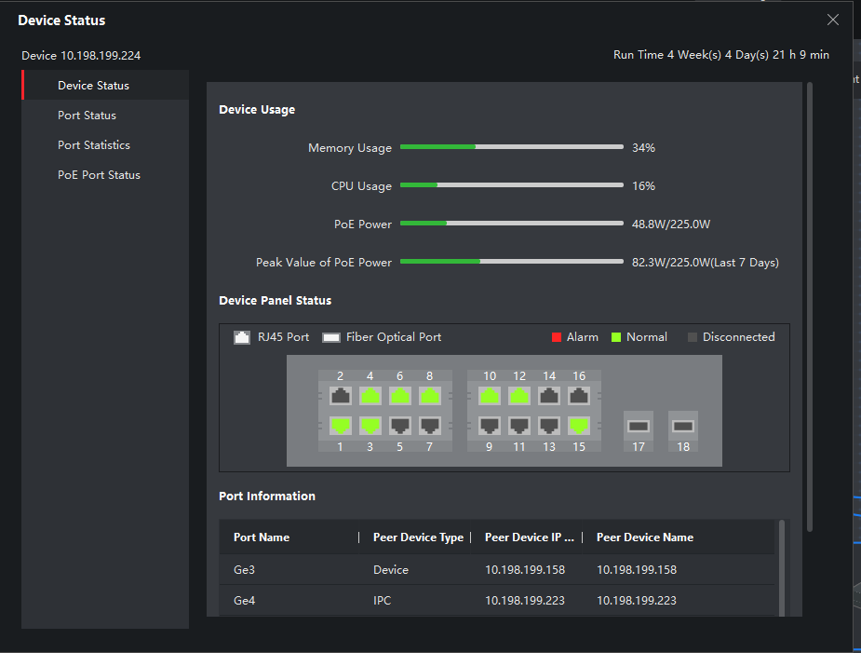
- Port Status will show you ports Name, Connectivity
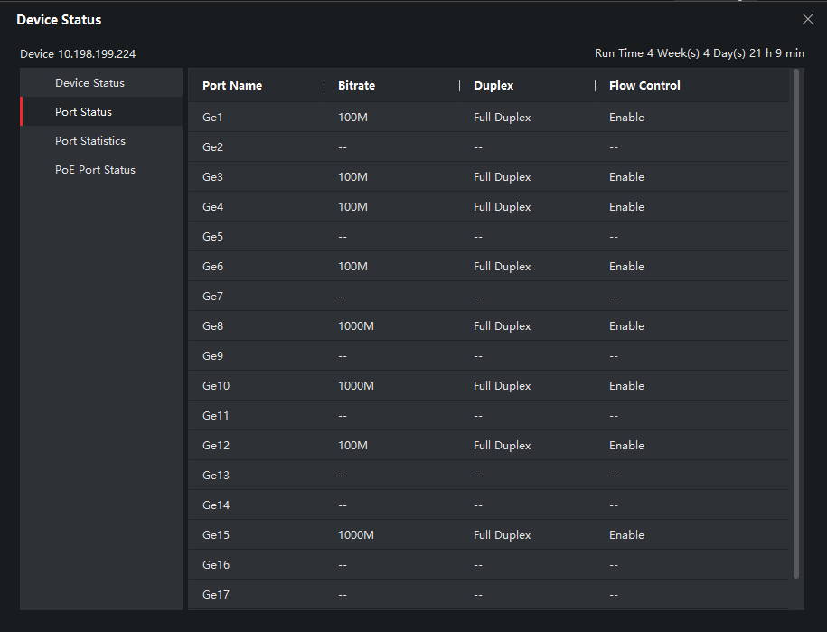

- Port Statistics will show each ports packets connectivity

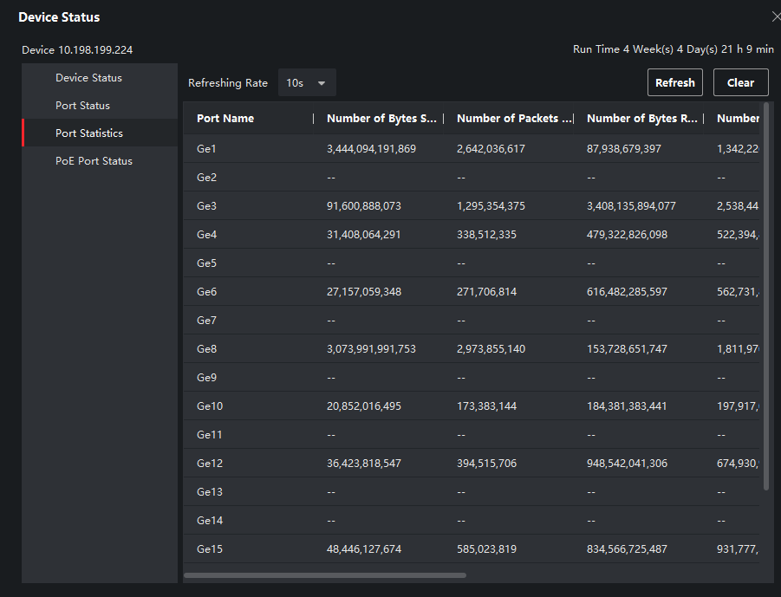

- POE Port Status will show the output power of each port individually.
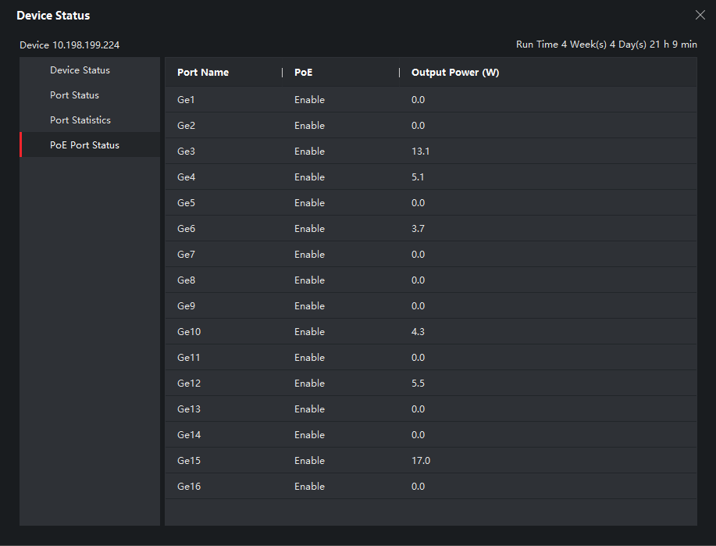

- Double click the blue line link between the Managed switch and the connected device will show the device connectivity detail and to which port its connected in the switch
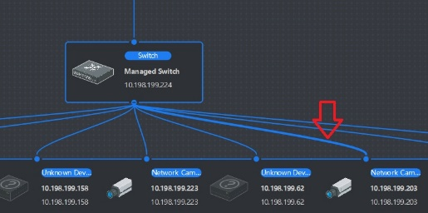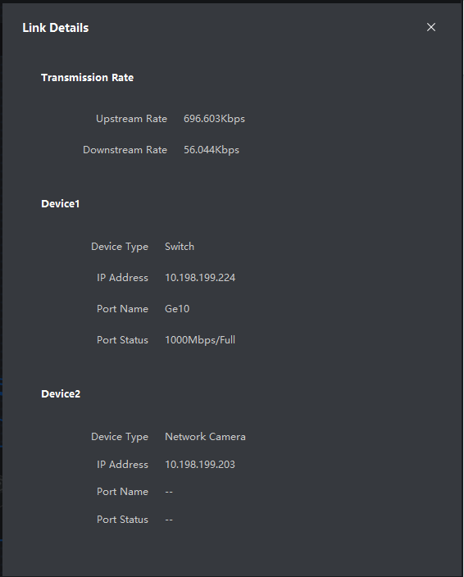

- To expand the topology hit ( + ) under the switch, ( Unknown Device) mostly will be unmanaged switch.

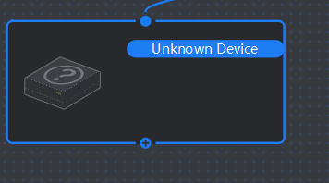
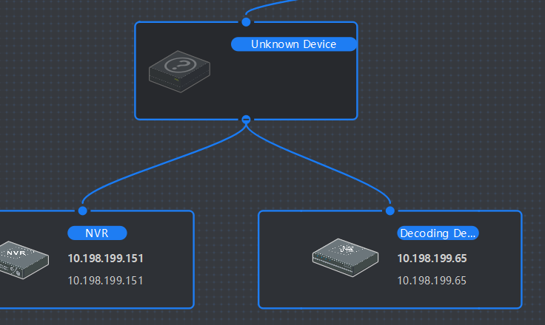

- To search for device in the topology you can either search by device name or IP in search bar

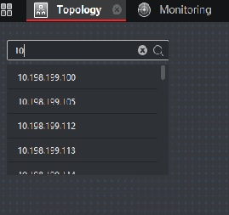

- To find the transmission (Path) between camera and NVR
- Hit the network icon (Top Right Side of the Topology)
- Enter the camera IP
- Choose the transmission device or NVR and hit OK
- To return to the Main Topology after search hit ( X ) beside showing path
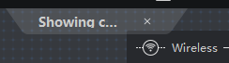
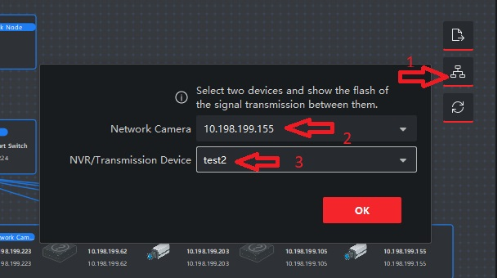
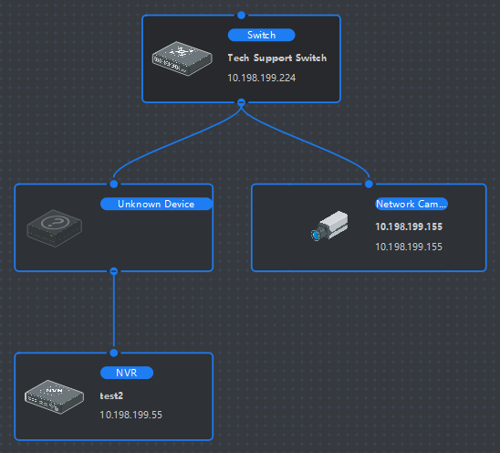
- The Topology can be exported as PDF for reference
